LAB REPORT
- Write a C program to print “Hello World.”
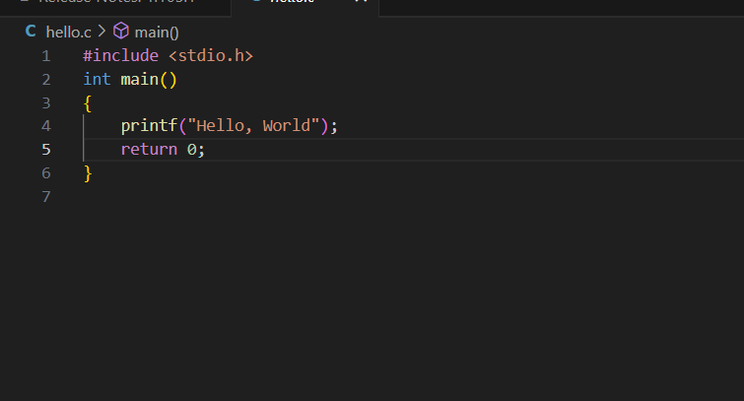

ALGORITHM
- Start
- Display “Hello World” on the screen
- Stop

FLOWCHART
Start

Stop

Print ”Hello World”

- Write a program to print address in multiple line.

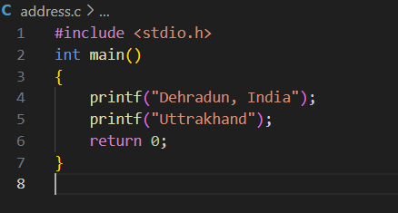
Stop
Print address (using printf multiple times)
Start

Algorithms
- Start.
- Use the printf() function to display the name on the first line.
- Use the \n escape sequence to move to the next line.
- Display the house number and street on the second line.
- Use \n again to move to the next line.
- Display the city and pin code on the third line.
- End.

Psuedocode
- Start
- Declare a string variable for each line of the address (e.g., line1, line2, line3, etc.).
- Assign values to these variables with the respective parts of the address.
  - Example:
    - line1 = "House Number, Street Name"
    - line2 = "City, State"
- Use the printf function to print each line of the address on a new line.
- End.

- Write a program that prompts the user to enter their name and age.

- Start
- Declare variables: name (string) and age (integer).
- Print a message: "Enter your name: ".
- Read the input and store it in the variable name.
- Print a message: "Enter your age: ".
- Read the input and store it in the variable age.
- Print the message: "Your name is [name] and your age is [age].".
- End

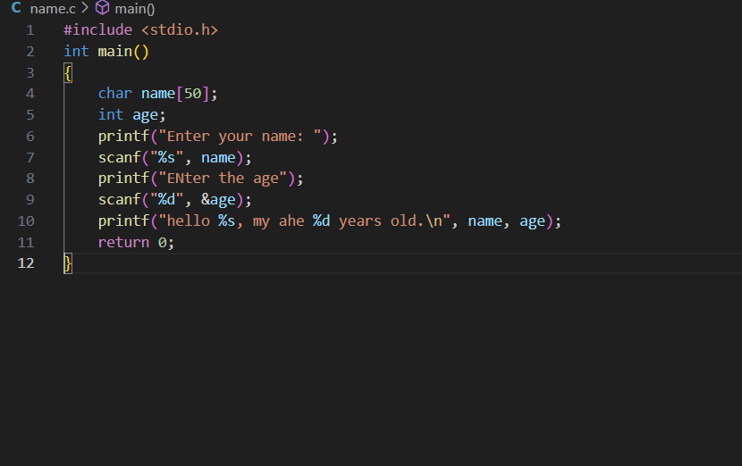

Start
Print name and age using printf

Stop
Input name and age using scanf

Algorithm
- Start.
- Declare variables for name (string) and age (integer).
- Assign values to the variables (e.g., your name and age).
- Use the printf() function to display the name and age.
- End.

- Write a C program to add two numbers, take number from user.

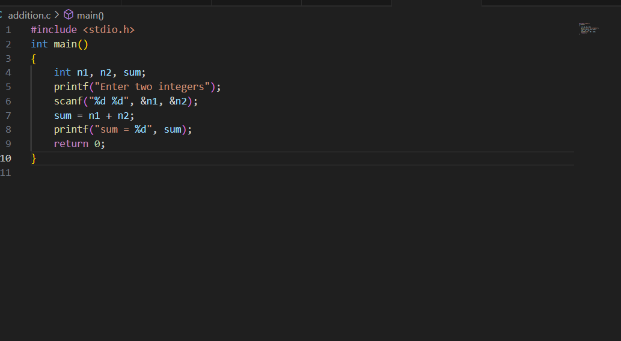

Psuedocode
- Start
- Declare variables num1, num2, and sum.
- Prompt the user to enter the first number and store it in num1.
- Prompt the user to enter the second number and store it in num2.
- Calculate the sum: sum = num1 + num2.
- Display the value of sum.
- Stop

Algorithm
- Start
- Declare three variables: num1, num2, and sum.
- Prompt the user to input two numbers.
- Read the values of num1 and num2.
- Calculate the sum: sum = num1 + num2.
- Display the result.
- End

Stop
Print sum using printf
Calculate sum = a + b
Input two numbers using scanf
Start

Experiment 2 : Operators
- WAP a C program to calculate the area and perimeter of a rectangle based on its length and width.

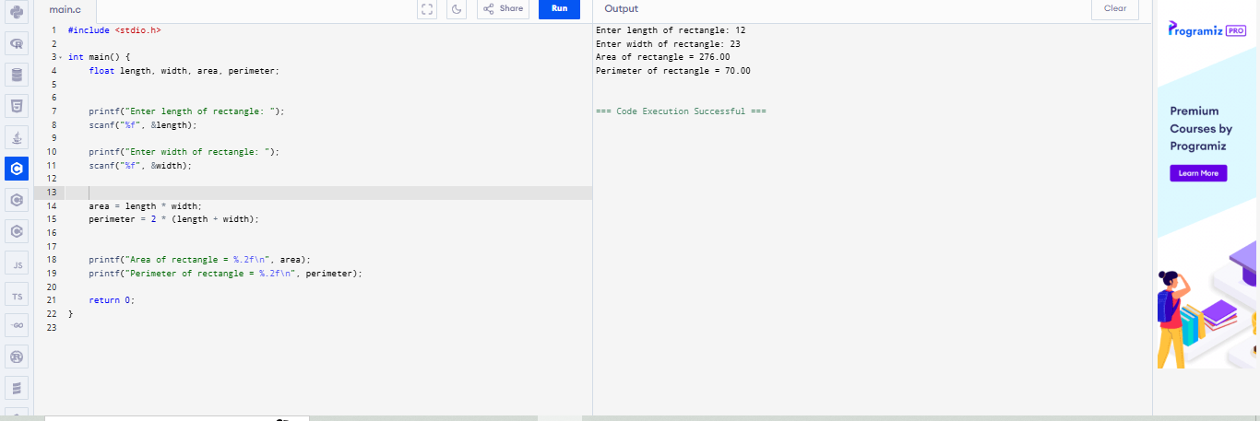

Algorithm
- Input Dimensions: Accept length and width as inputs from the user.
- Calculate Area: Multiply length by width.
- Calculate Perimeter: Add length and width, then multiply by 2.
- Output Results: Display both the area and perimeter.

Psuedocode

int length, width;

// Prompt user for input
Print("Enter the length of the rectangle: ");
Input(length);

Print("Enter the width of the rectangle: ");
Input(width);

// Calculate area and perimeter
int area, perimeter;
area = length * width;
perimeter = 2 * (length + width);

// Display the results
Print("Area of the rectangle: ", area);
Print("Perimeter of the rectangle: ", perimeter);

Flowchart

Start

Stop
Perimeter = 2(l*b)
Area = l * b
Perimeter = 2(l*b)
Area = l * b
Input l,b,area,perimeter

2 .WAP to convert temperature Celsius to Fahrenheit using the formula f = (c*9/5) + 32
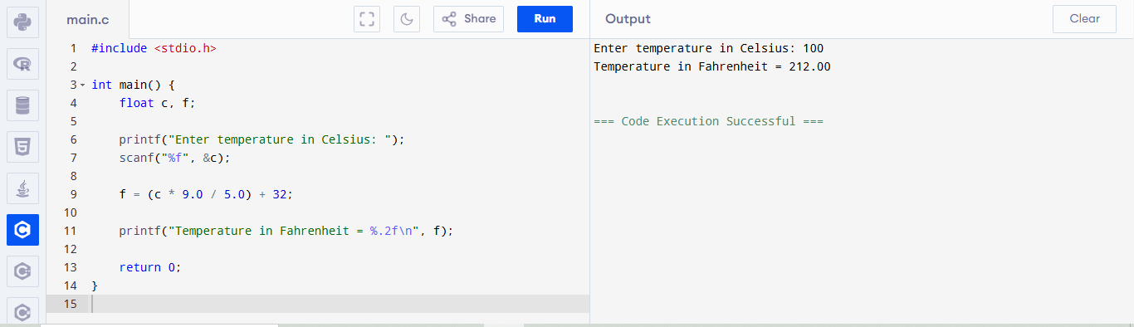

Psuedocode
START
INPUT Celsius
Fahrenheit ← (Celsius * 9 / 5) + 32
OUTPUT Fahrenheit
END
Algorithm
- Start
- Input the temperature in Celsius (C).
- Calculate the temperature in Fahrenheit using the formula:
  - F = C × 9/5 + 32
- Output the temperature in Fahrenheit (F).
- End
Flowchart
Stop
Display the value of fahrenheit
Fahrenheit =( Celsius*9/5) + 32
Initialize f = 0
Read the temperature in celsius and fahrenheit
Start

PROGRAM CHECK IF THE TRIANGLE IS VALID OR NOT. IF THE VALIDITY IS ESTABLISHED, DO CHECK IF THE TRIANGLE IS ISOSCELES, EQUILATERAL, RIGHT ANGLE OR SCALENE. TAKE SIDES OF THE TRIANGLE AS INPUT FROM USER."
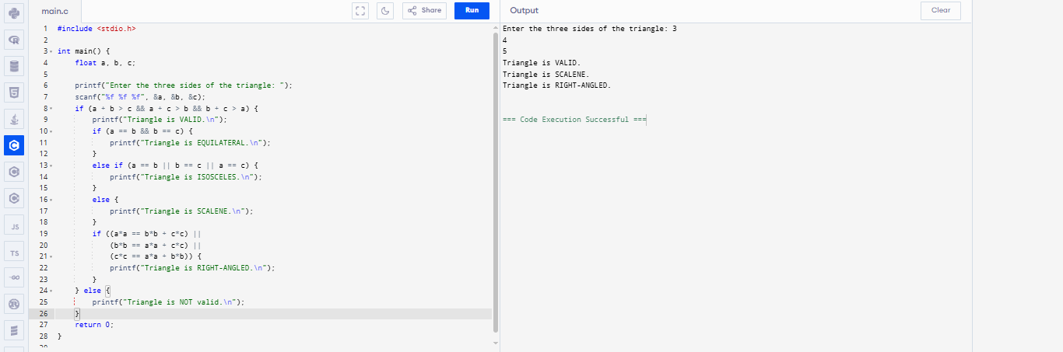

Algorithm
Step 1: Input
- Read three sides of the triangle: a, b, and c.
Step 2: Check Triangle Validity
- A triangle is valid if all of the following conditions are true:
  - $a+b>c$
  - $b+c>a$
  - $a+c>b$
- If valid, proceed to classification.
- Else, print: "Triangle is not valid." and stop.
Step 3: Classify the Triangle
- Condition: $a=b=c$
- Action: Print "Equilateral triangle."
3.2 Isosceles Triangle
- Condition: $a=b$or $b=c$or $a=c$
- Action: Print "Isosceles triangle."
3.3 Right-Angled Triangle
- Condition: Any one of the following is true:
  - $a^{2}+b^{2}=c^{2}$
  - $b^{2}+c^{2}=a^{2}$
  - $a^{2}+c^{2}=b^{2}$
- Action: Print "Right-angled triangle."
3.4 Scalene Triangle
- Condition: $a≠b≠c$
- Action: Print "Scalene triangle."
Psuedocode
START

// Step 1: Input
READ a, b, c

// Step 2: Check triangle validity
IF (a + b > c) AND (b + c > a) AND (a + c > b) THEN
PRINT "Triangle is valid"

// Step 3: Classification

IF (a == b) AND (b == c) THEN
PRINT "Equilateral triangle"

ELSE IF (a == b) OR (b == c) OR (a == c) THEN
PRINT "Isosceles triangle"

ELSE IF (a^2 + b^2 == c^2) OR (b^2 + c^2 == a^2) OR (a^2 + c^2 == b^2) THEN
PRINT "Right-angled triangle"

ELSE
PRINT "Scalene triangle"

ELSE
PRINT "Triangle is not valid"

END
Flowchart
Check triangle validity
Triangle not valid
Input sides a,b,c
start

Yes
Triangle is valid

NO
Check isosceles
Triangle is valid

Yes
Isosceles triangle

No
Right angled triangle
Check right angled triangle

Yes
Scalene triangle
Scalene triangle
Stop

2Write a C program that prompts the user to enter their weight in kilograms and height in meters. The program should calculate the BMI using the formula:
Algorithm:
- Start
- Declare variables: weight, height, bmi as float.
- Prompt the user to enter their weight in kilograms.
- Read the value of weight.
- Prompt the user to enter their height in meters.
- Read the value of height.
- Calculate BMI using the formula:
$$\text{BMI}=\frac{\text{weight}}{\text{height}×\text{height}}$$
- Display the calculated BMI value.
- Use conditional statements to determine the BMI category:
  - If BMI < 15 → Starvation
  - If BMI ≥ 15 and < 17.5 → Anorexic
  - If BMI ≥ 17.5 and < 18.5 → Underweight
  - If BMI ≥ 18.5 and < 25 → Ideal
  - If BMI ≥ 25 and < 30 → Overweight
  - If BMI ≥ 30 and < 40 → Obese
  - If BMI ≥ 40 → Morbidly Obese
- Display the corresponding BMI category.
- End
Pseudocode
Start

Declare variables: weight, height, bmi as float

Display "Enter your weight in kilograms:"
Read weight

Display "Enter your height in meters:"
Read height

Compute bmi = weight / (height * height)

Display "Your BMI is: ", bmi

If bmi< 15
Display "Category: Starvation"
Else if bmi>= 15 and bmi< 17.5
Display "Category: Anorexic"
Else if bmi>= 17.5 and bmi< 18.5
Display "Category: Underweight"
Else if bmi>= 18.5 and bmi< 25
Display "Category: Ideal"
Else if bmi>= 25 and bmi< 30
Display "Category: Overweight"
Else if bmi>= 30 and bmi< 40
Display "Category: Obese"
Else
Display "Category: Morbidly Obese"

End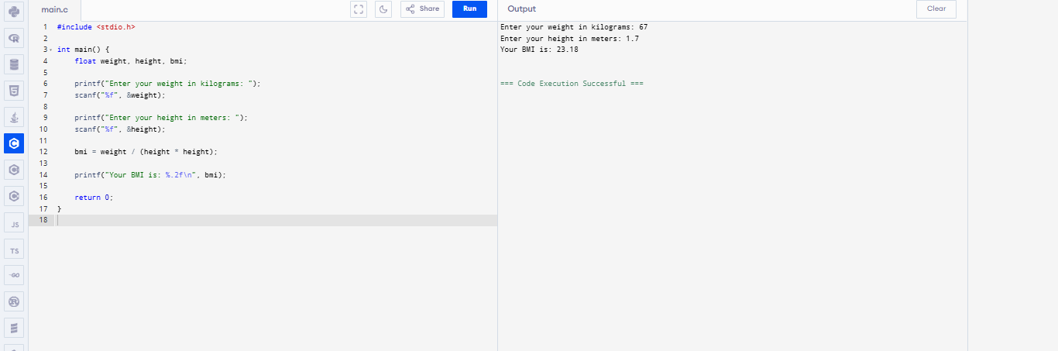

Flowchart
Display underweight
BMI <15 ?
Display BMI value
Calculate :BMI = weight/height * height
Input weight (kg)
start

NO

Yes
BMI <17.6 ?

BMI < 16.5 ?
NO
Display “IDEAL”

YES
Display “OVERWEIGHT”
BMI <30 ?
BMI <25 ?
YES

NO
BMI < 40 ?

YES
STOP

To determine whether three points lie on the same straight line using coordinate geometry.
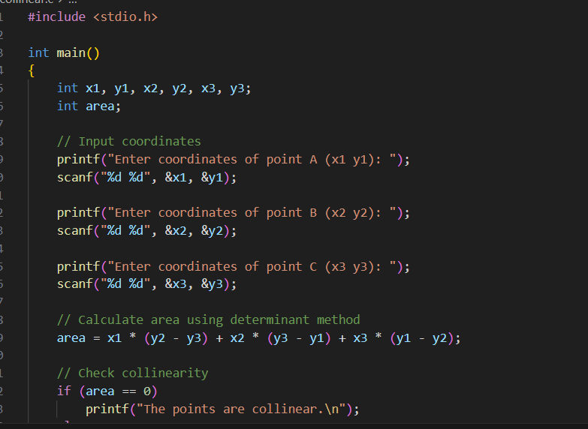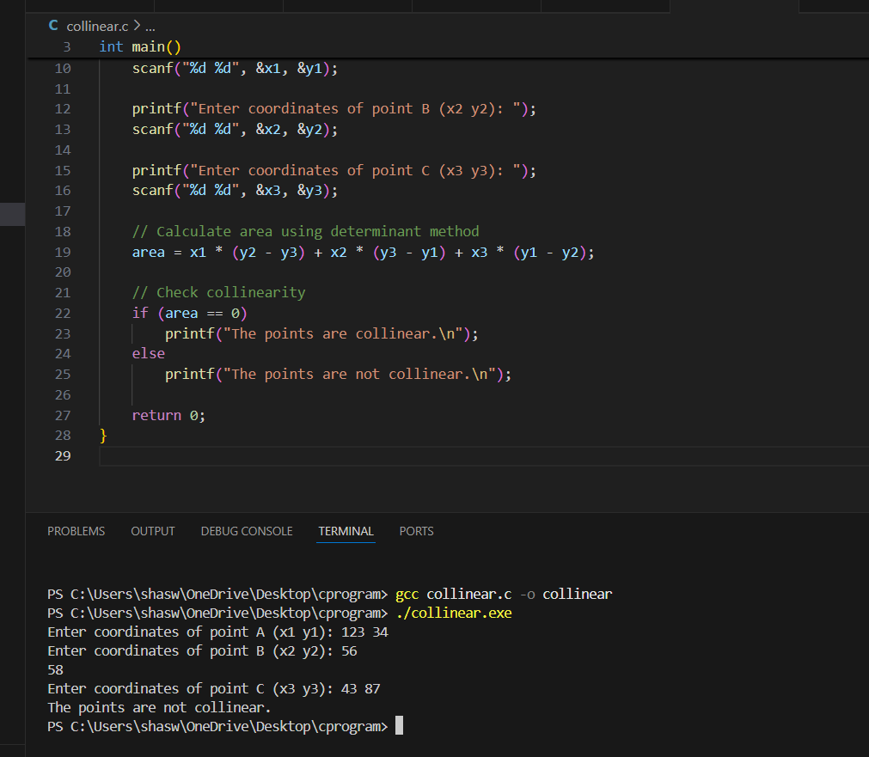

Algorithm
- Start
- Input coordinates of three points:
  - Point A: $(x_{1},y_{1})$
  - Point B: $(x_{2},y_{2})$
  - Point C: $(x_{3},y_{3})$
- Compute the area using the formula:
$$\text{Area}=x_{1}(y_{2}-y_{3})+x_{2}(y_{3}-y_{1})+x_{3}(y_{1}-y_{2})$$
- Check if Area == 0
  - If true, then the points are collinear
  - Else, the points are not collinear
- Display the result
- End
PSUEODOCODE
START

// Step 1: Input coordinates of three points
READ x1, y1
READ x2, y2
READ x3, y3

// Step 2: Compute area using determinant formula
SET area ← x1 * (y2 - y3) + x2 * (y3 - y1) + x3 * (y1 - y2)

// Step 3: Check if area is zero
IF area == 0 THEN
PRINT "The points are collinear"
ELSE
PRINT "The points are not collinear"
END IF

END
FLOWCHART
START
Points are not collinear
Compute area using :x1(y2 -y3) + x2(y3 – y1) + x3(y1 – y2)
INPUT COORDINATES
(x1,y1),(x2,y2),(x3,y3)

NO
Points are collinear
IS area = 0 ?

STOP

